

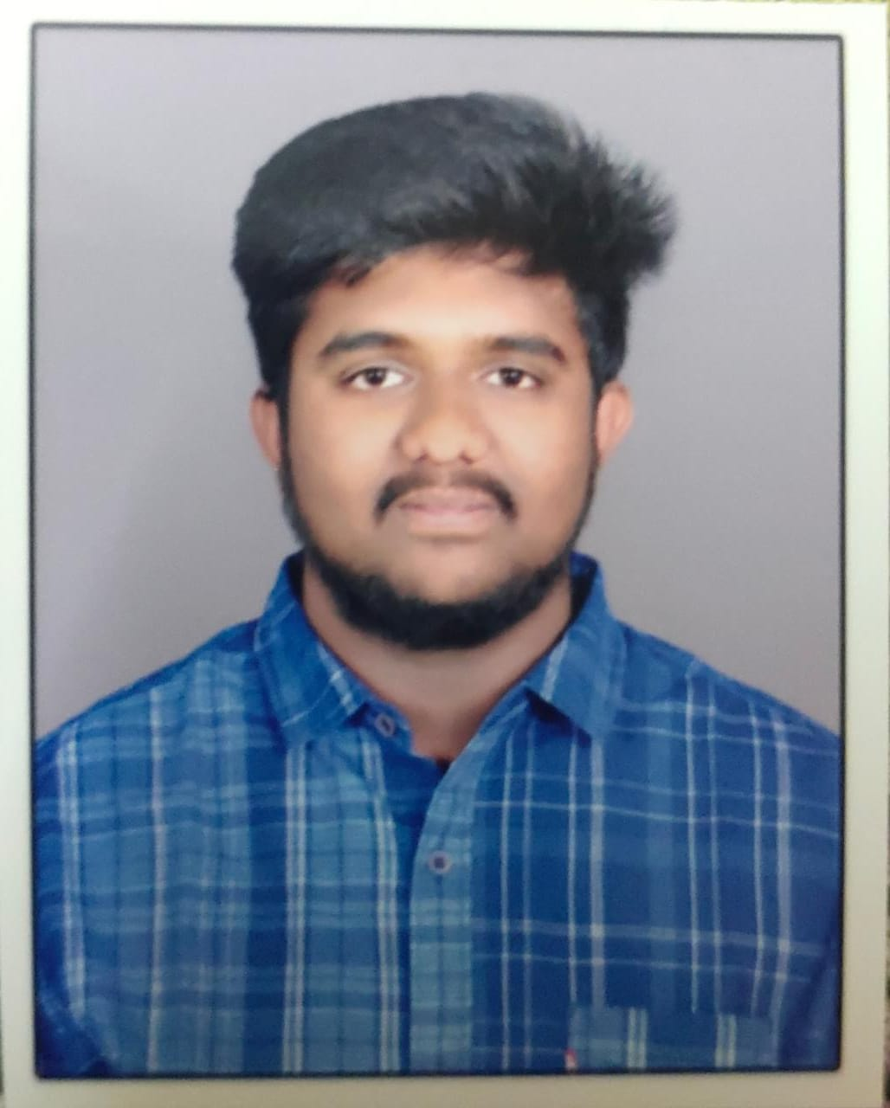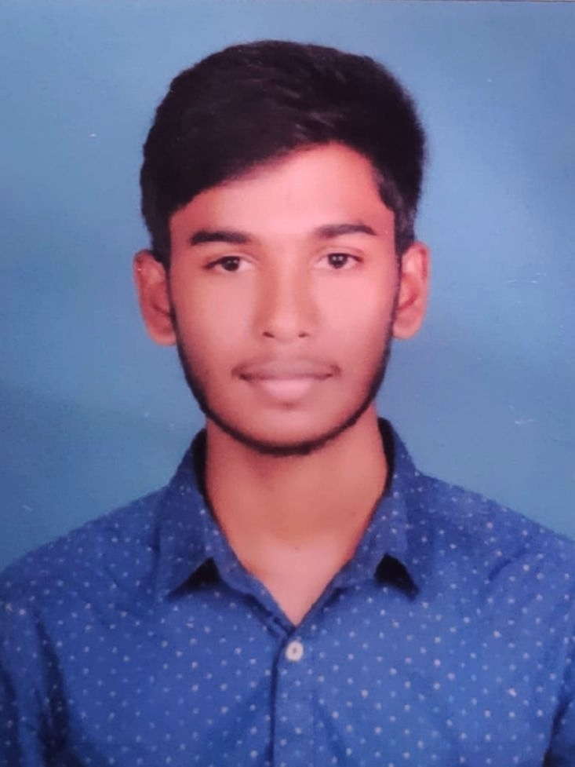

**GOKULNITHI.R**

**B.TECH Information Technology**

8825792784



gokulrajendran04@gmail.com



Description: in logo.png https://www.linkedin.com/in/gokul-nithi-59a300230

|  |
| --- |
| **CAREER OBJECTIVE** |

Seeking challenging opportunities in order to develop and implement the knowledge deep about the field and to explore the new technology which in turn will help in accomplishment of organization goals and professional growth.

|  |
| --- |
| **SOFTWARE PROFICIENCY** |

* Programming Language : JAVA(Basics),DBMS
* Web Technologies : HTML,CSS
* Software : Visual Studio Code,MySQL,Pentaho

|  |
| --- |
| **CERTIFICATIONS** |

* Done a certified course on “Pentaho Fundamentals and Data Warehoures Concepts” on ‘Udemy’ in January 2021

|  |
| --- |
| **AREAS OF INTEREST** |

* Database Management System
* Java Programming
* Web developing
* Software Testing

|  |
| --- |
| **PROJECTS UNDERTAKEN** |

**Mini Project 1-**

Institution : Sri Shakthi Institute of Engineering and Technology

Duration : 2 Months

Project title : **Automatic Irrigation System**

Objective :Helps Farmers to irrigate the plants automatically

Tools Used :Arduino UNO,Arduino ide.

Status : Completed

**Mini Project 2**

Institution : Sri Shakthi Institute of Engineering and Technology

Duration :2 Months

Project title : **Online Exam Management System**

Objective : To allow students to write exam online

Tools Used :JSP,MySQL

Status : Completed

**Main Project 3 - Core**

Institution : Sri Shakthi Institute of Engineering and Technology

Duration :2 Months

Project title : **Face Recognition Based Attendance System**

Objective : Marks Attendance Based on Face

Tools Used :JSP,MySQL

|  |
| --- |
| **EXTRA – CURRICULAR ACTIVITIES** |

* Basketball
* Photography
* Anchoring

|  |
| --- |
| **KEY STRENGTHS** |

* Decision Making
* Self Confidence
* Dedication
* Logical Thinking
* Team Work

|  |
| --- |
| **ACADEMIC CREDENTIALS** |

|  |  |  |  |  |  |  |  |  |  |  |  |  |  |  |  |  |  |  |  |  |  |  |  |  |
| --- | --- | --- | --- | --- | --- | --- | --- | --- | --- | --- | --- | --- | --- | --- | --- | --- | --- | --- | --- | --- | --- | --- | --- | --- |
| |  |  |  |  |  |  | | --- | --- | --- | --- | --- | --- | | **S.No** | **Course** | **Name of Institution** | **University/ Board** | **Year of Passing** | **CGPA/ %** | | **1** | B.TECH-IT | Sri Shakthi Institute of Engineering and Technology | Anna university | 2023 | 7.47  (upto 4thsem) | | **2** | HSC | Vidhyaa vikas Matric Hr Sec School | State board | 2019 | 59% | | **3** | SSLC | Vidhyaa vikas Matric Hr Sec School | State board | 2017 | 86.4% | |

|  |
| --- |
| **PERSONAL DETAILS** |

Date of Birth :04.08.2001

Gender : Male

Father’s Name :R.Rajendran

Languages known

Speak: Tamil, English

Read &Write:Tamil, English

Nationality : Indian

Mobility : Willing to relocate any where in India and abroad

Address for Communication:109(1) Padakkey Street-3,Ondipudur,Coimbatore,Tamilnadu-641016

**DECLARATION**

I, hereby declare that the above information is true to the best of my knowledge.

Place: Coimbatore (Signature)

Date: GOKULNITHI.R